Appendix F: Work Flow Implementation

7.6.1. Sequence Diagrams:

Sequence diagram for Teacher:

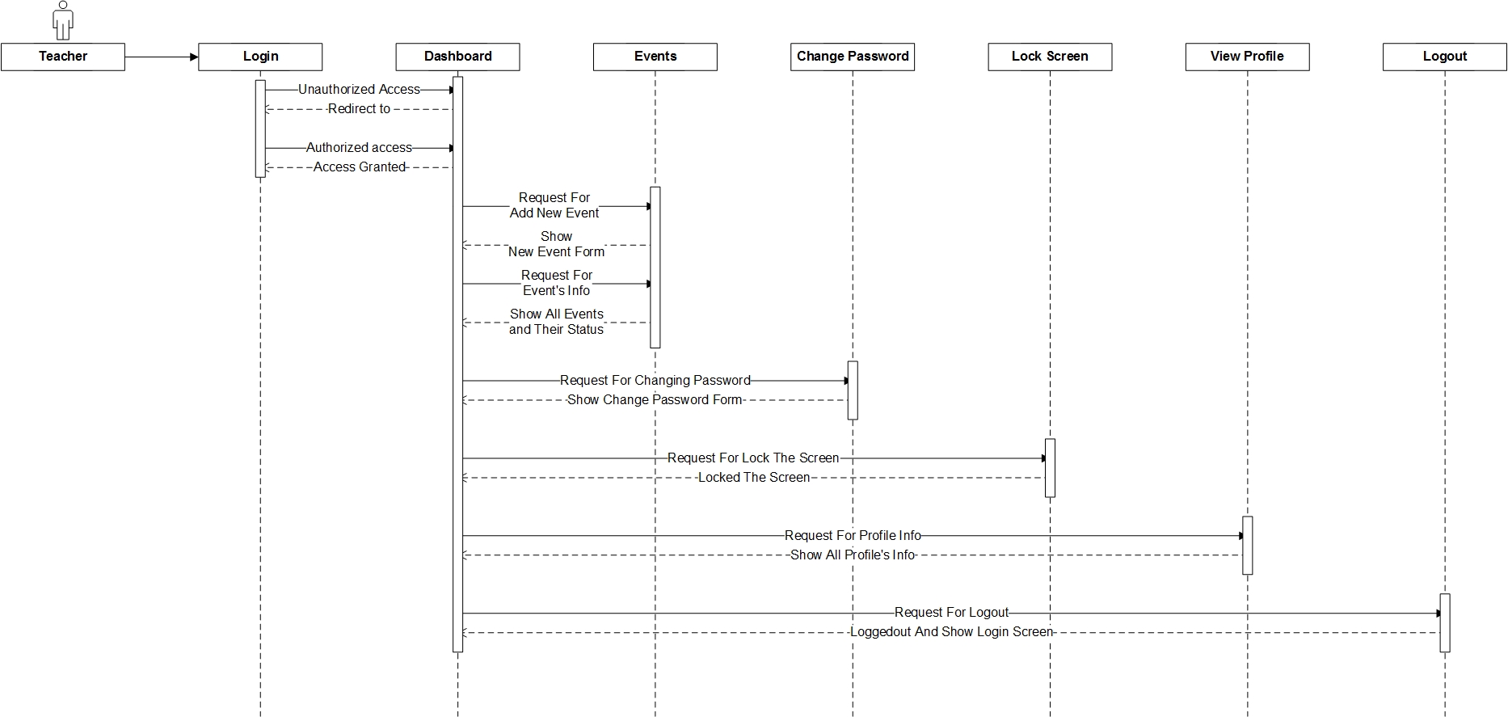

Figure: teacher’s sequence

Sequence diagram for admin:

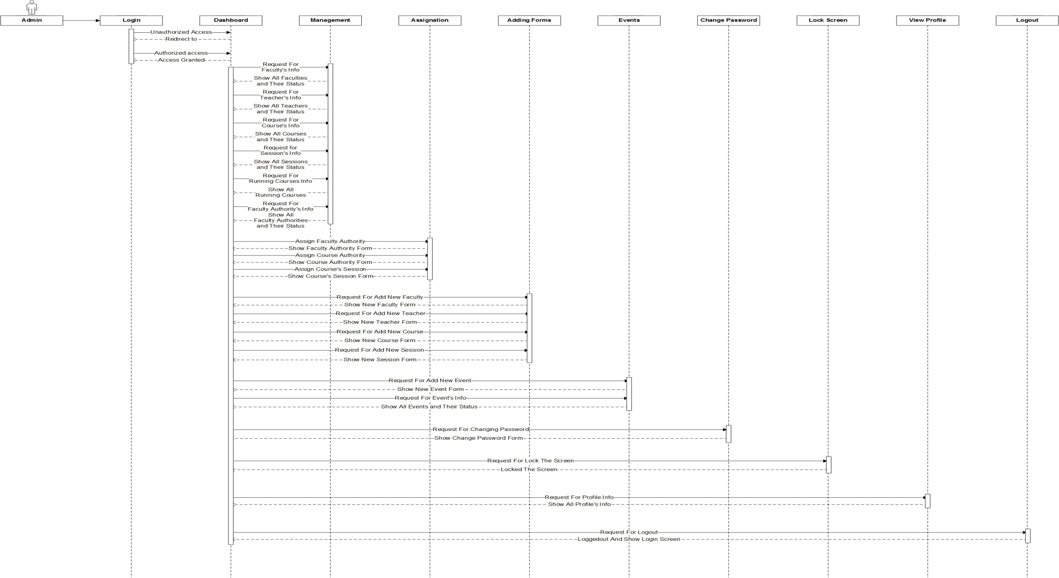

Figure: Admin’s sequence

Sequence diagram for Course Leader:

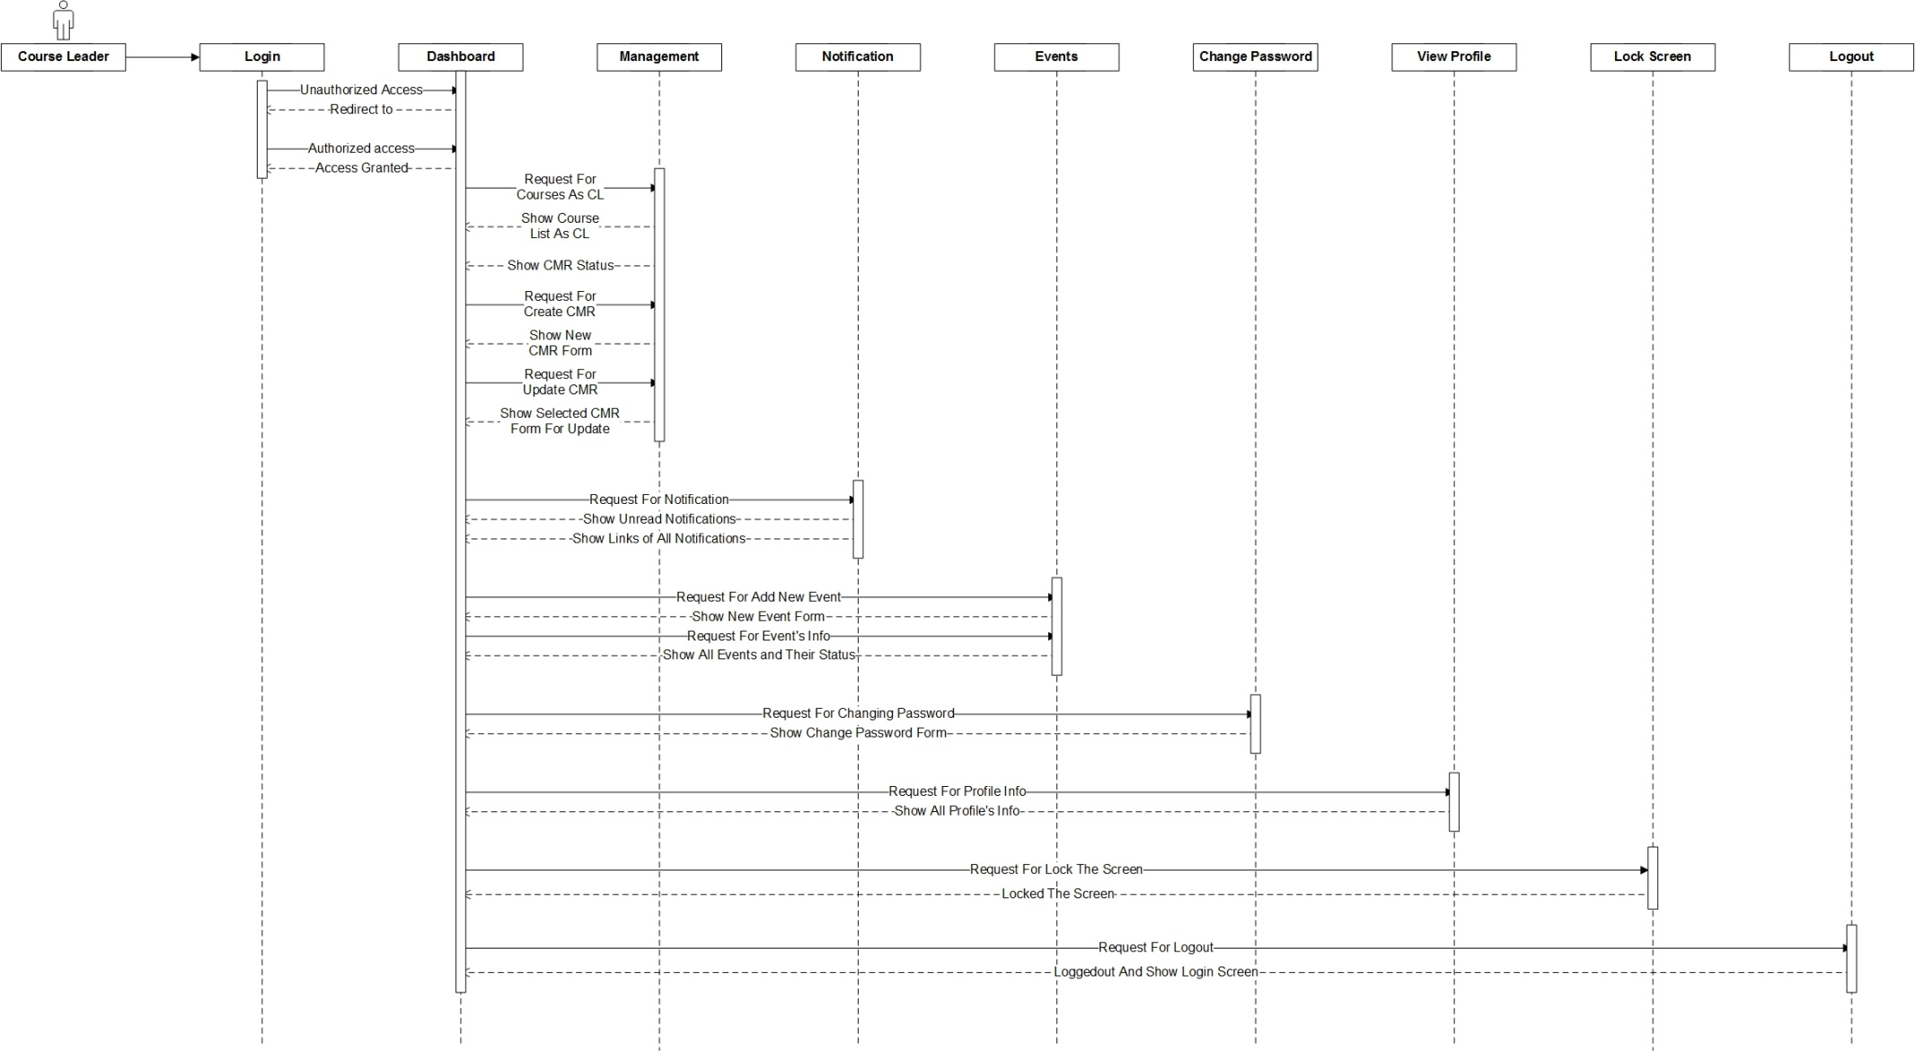

Figure: CL’s Sequence

Sequence diagram for Course Moderator:

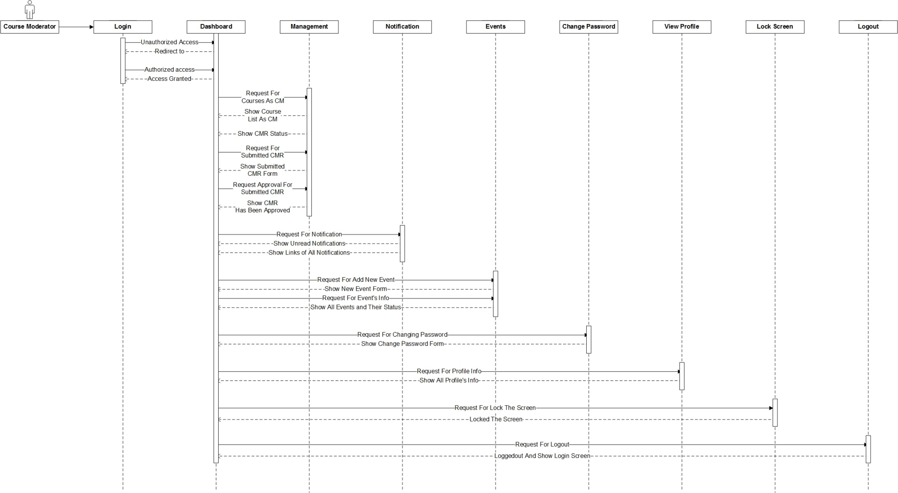

Figure: CM’s Sequence

Sequence Diagram for Pro-vice Chancellor:

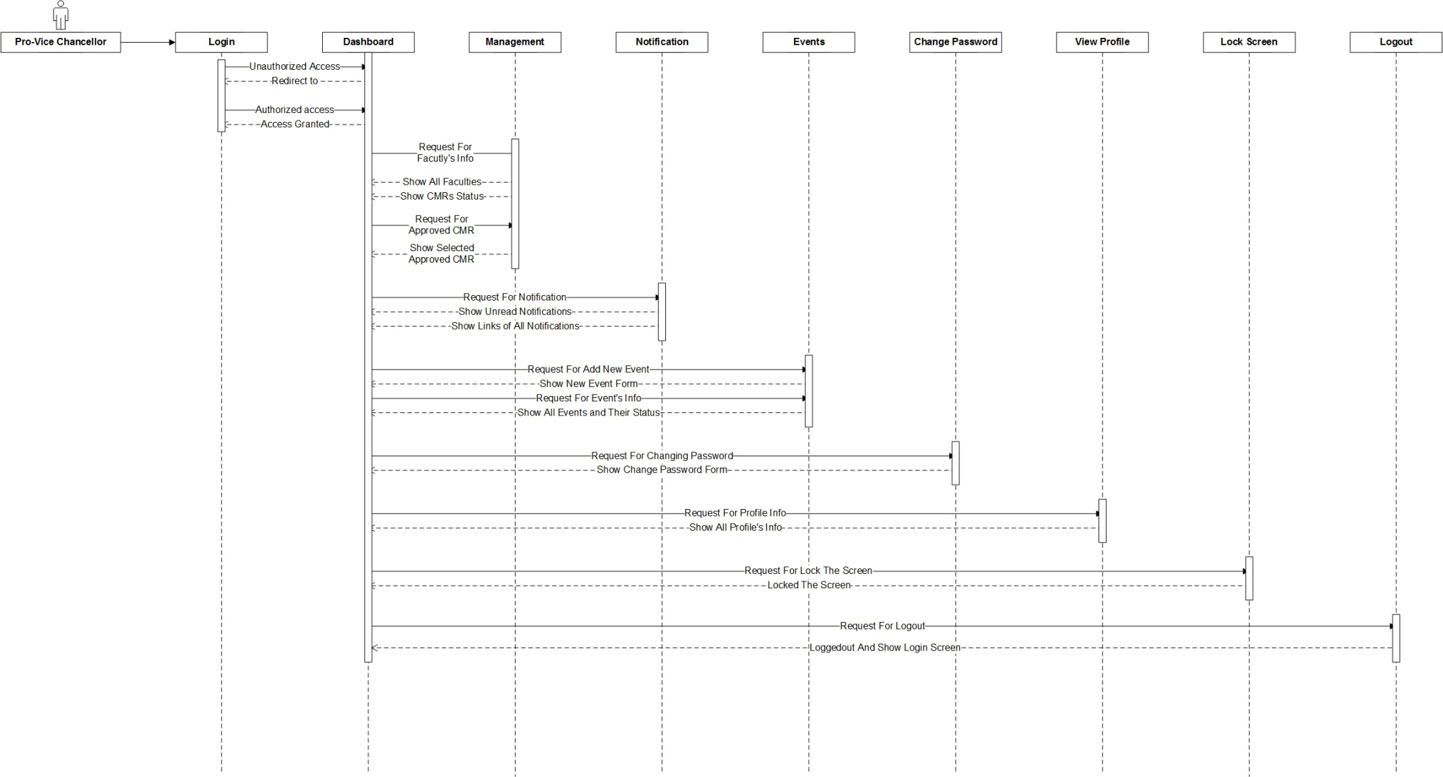

Figure: PVC’s Sequence

Sequence Diagram for Director of Learning & Quality:

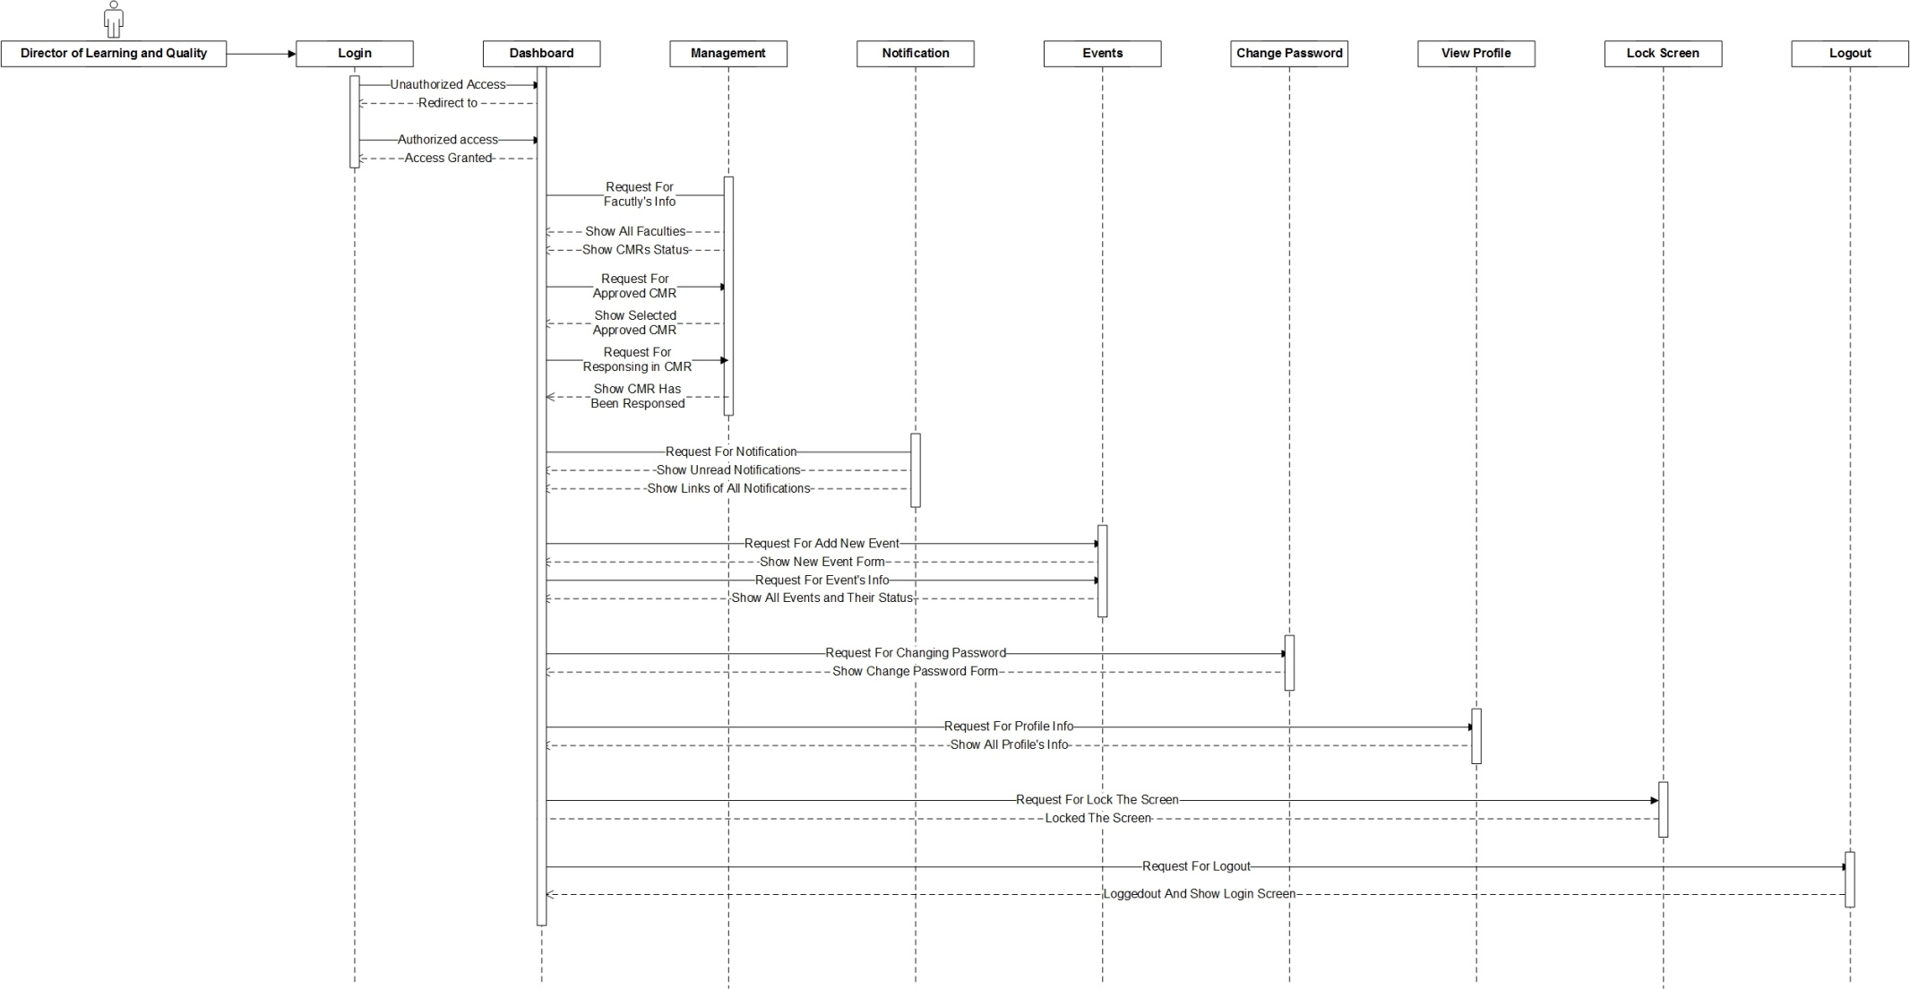

Figure: DLT’s Sequence

Sequence Diagram for Guest Account:

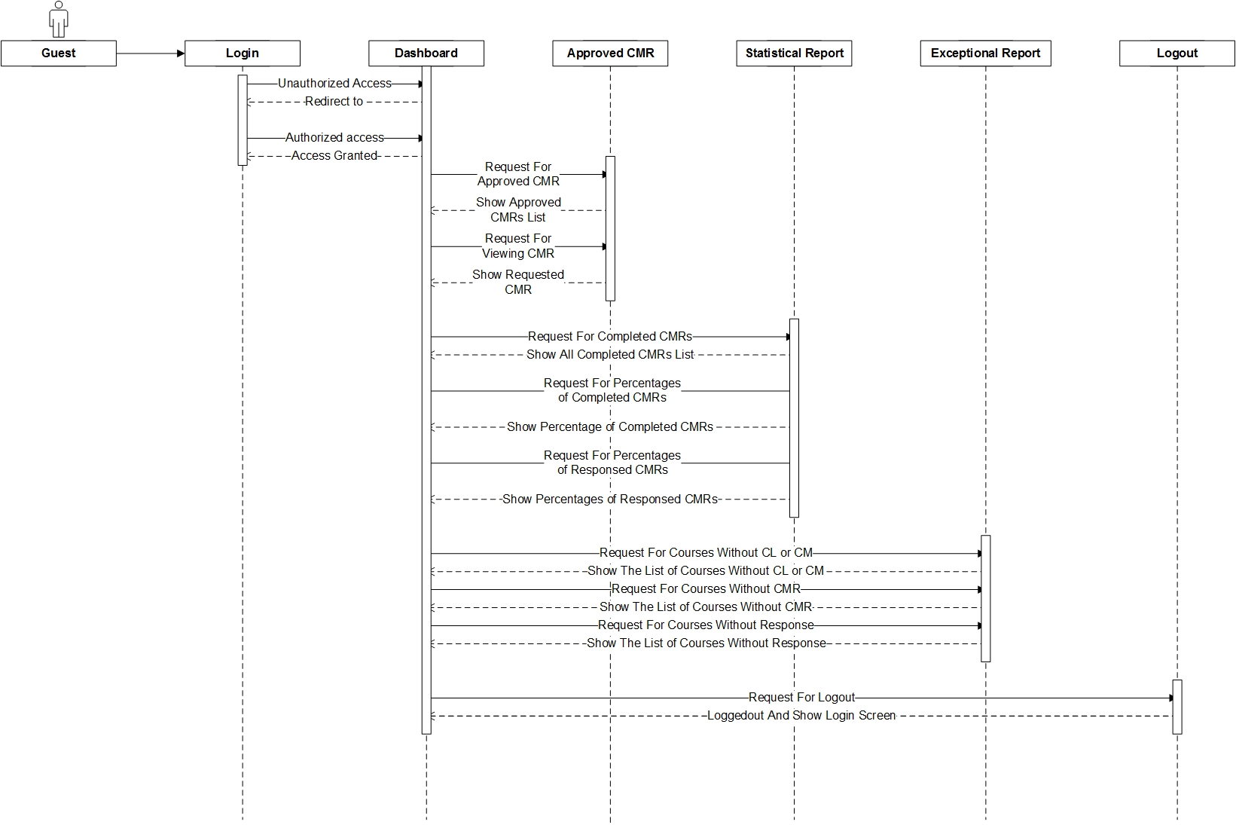

Figure: Guest’s Sequence